**Hotel Management System**

**Standard Version**

**Guide**

**Front Desk Guide**

1. How to login
2. How to How to add a guest
3. How to Book a Room
4. How to check out of a room
5. How to Generate Reports
6. How to manage your guests
7. How to Handle your Payments
8. How to manage Food Orders
9. How to make an important note

**Admin Desk Guide**

1. How to manage your users
2. How to manage your Staff

1. **How to login**

If you first start your system, you can use the default Front Office Dashboard to login it. Its password is empty, as the figure 1 shows, you can just click Login button to login your system and get all permissions:

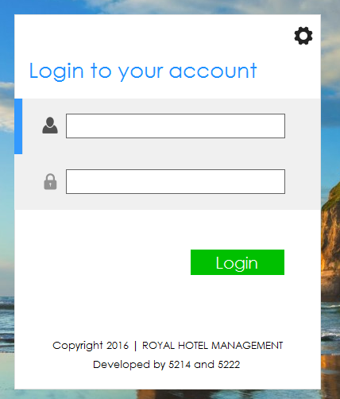

If you are a staff member of this hotel, you can login with your user name and password. Of course, you should ensure that you already are allowed login this system. If you want to add some users, please refer to Chapter 8.

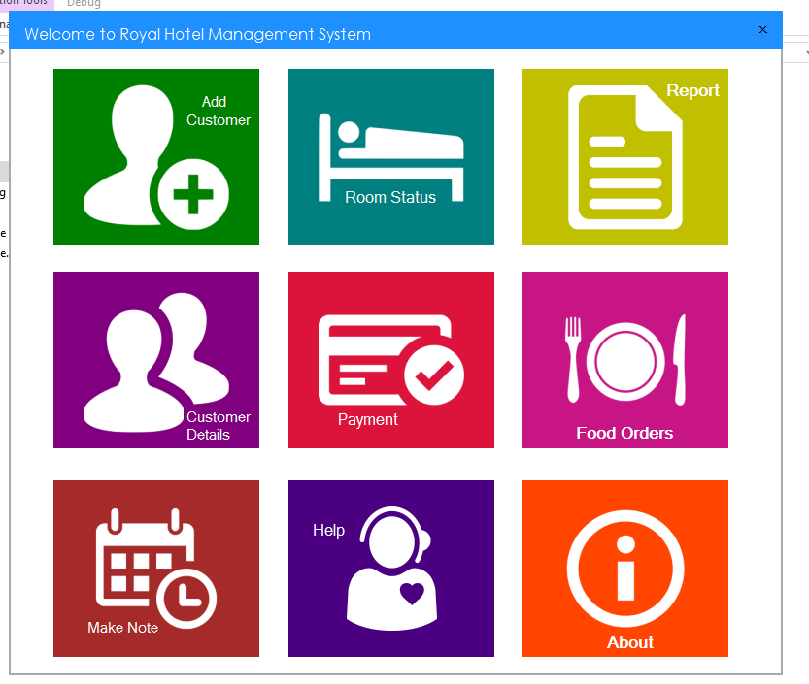

FrontDesk Dashboard

1. **How to add a guest**

Step 1: Click On the Add Customer Button in the FrontDesk Dashboard

Step 2: Fill In the details properly as per given by the customer

NOTE: Proof refers to the Identification proof the Guest shows during Booking

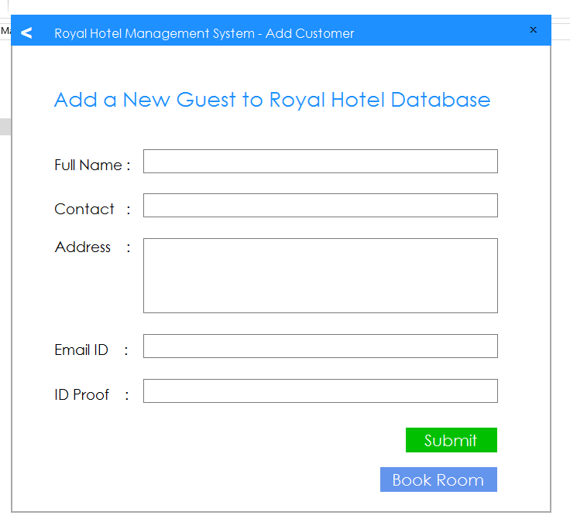

Step 3: Click on the “SUBMIT” Button.

Step 4: A Dialogue Box appears asking permission click on OK

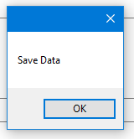

Here you have successfully added a new Guest to your system.

1. **How to Book a Room**

Step 1: Click on the Room Status Button in the FrontDesk Dashboard

Step 2: The Page shows the status of Rooms.

i.e. GREEN = Rooms Available

RED = Rooms Booked

ORANGE = Rooms Under Maintenance

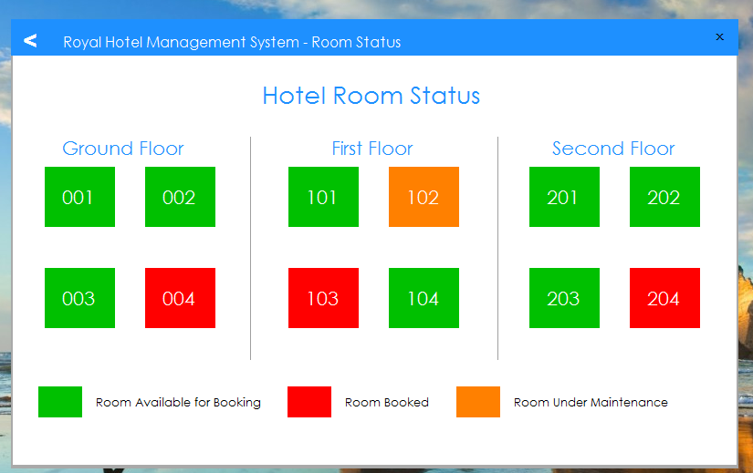

Step 3: Click on the Room available.

Step 4: Fill in the Details.

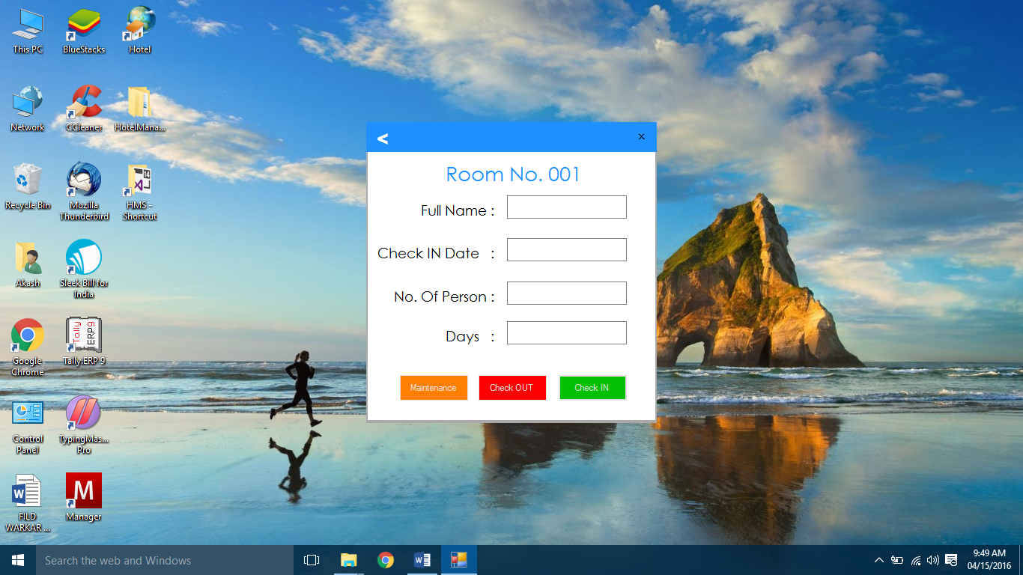

Step 5: Click on CHECK IN to book the ROOM.

1. **How to Check Out of a Room**

Step 1: Click on the room you want to check out.

Step 2: Click on the CHECK OUT Button to check out.



1. **How to Generate Report**

Step 1: Click on the REPORT Button in the FrontDesk Dashboard

Step 2: Shows that you can generate three types of reports.

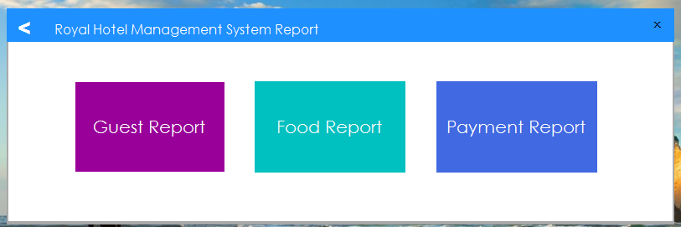

Step 3: Please Refer Chapter 6, 7 & 8 for further details

1. **How to Manage your Guest**

Step 1: Click on the CUSTOMER DETAILS Button in the FrontDesk Dashboard

Step 2: You get to see three buttons.

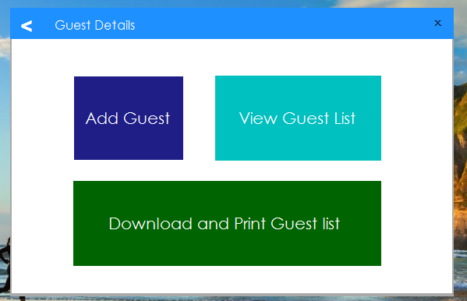

Step 3: To ADD Guest, Please refer Chapter 2.

Step 4: To view the Guest List Click on the View Guest List Button.

Step 5: Click On load Data to See the Data.

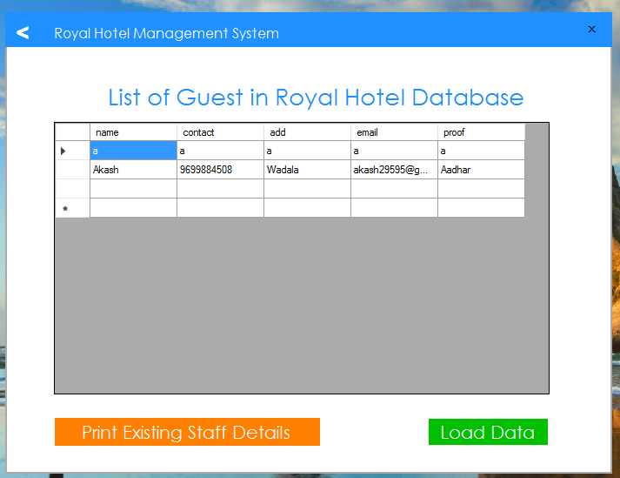

Step 6: Click on PRINT EXISTING STAFF DETAILS to Download & Print Data.

1. **How to Manage your Payment**

Step 1: Click on the PAYMENT Button in the FrontDesk Dashboard

Step 2: You get to see three buttons.

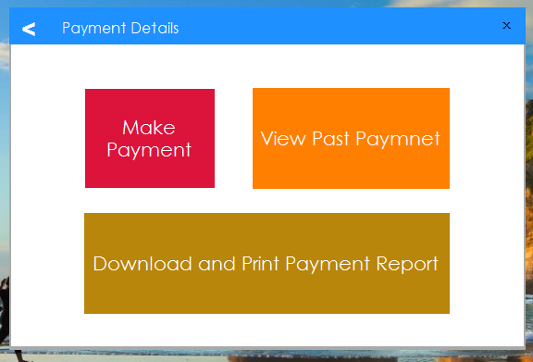

Step 3: To ADD Payment, Click on INCOME or EXPENSE Depending on your PAYMENT

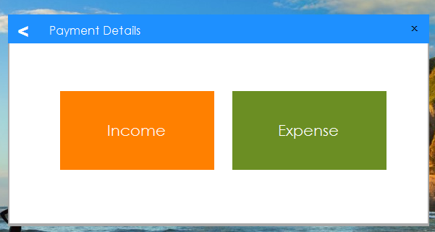

Step 4: Fill in the Details accordingly.

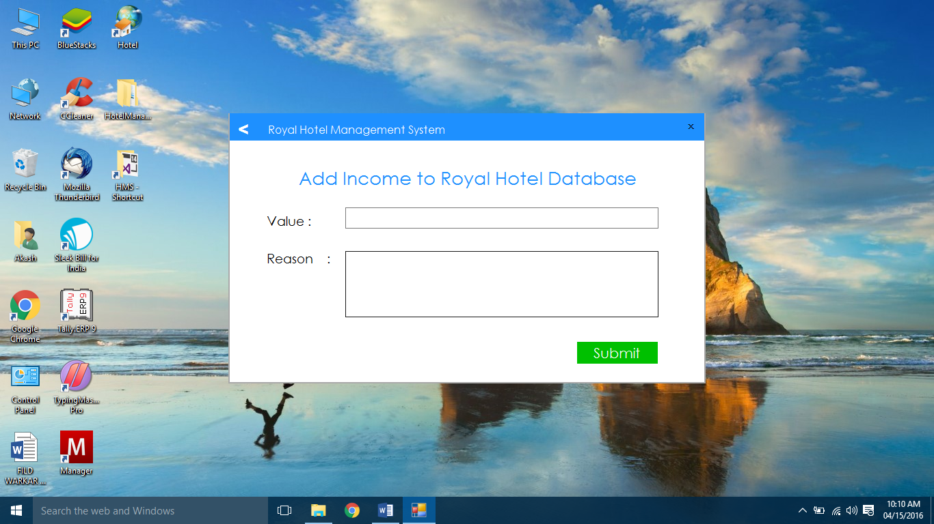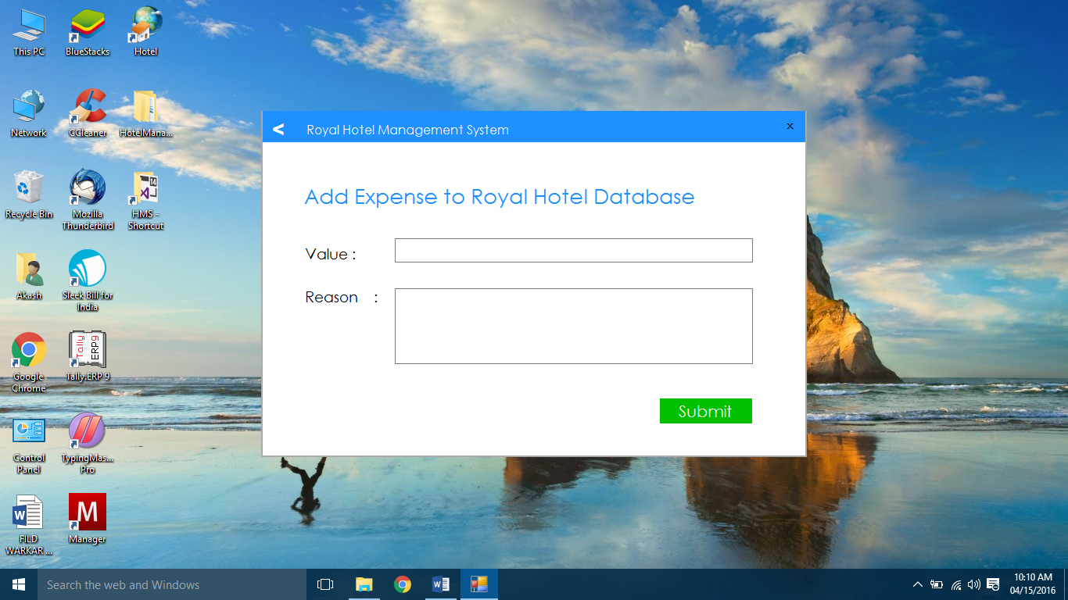

Step 5: Click on submit to save data.

Step 6: To View DATA go back and click on VIEW PAYMENT Button. And Select the Type of Payment.



Step 7: Click on LOAD DATA to view the DATA.

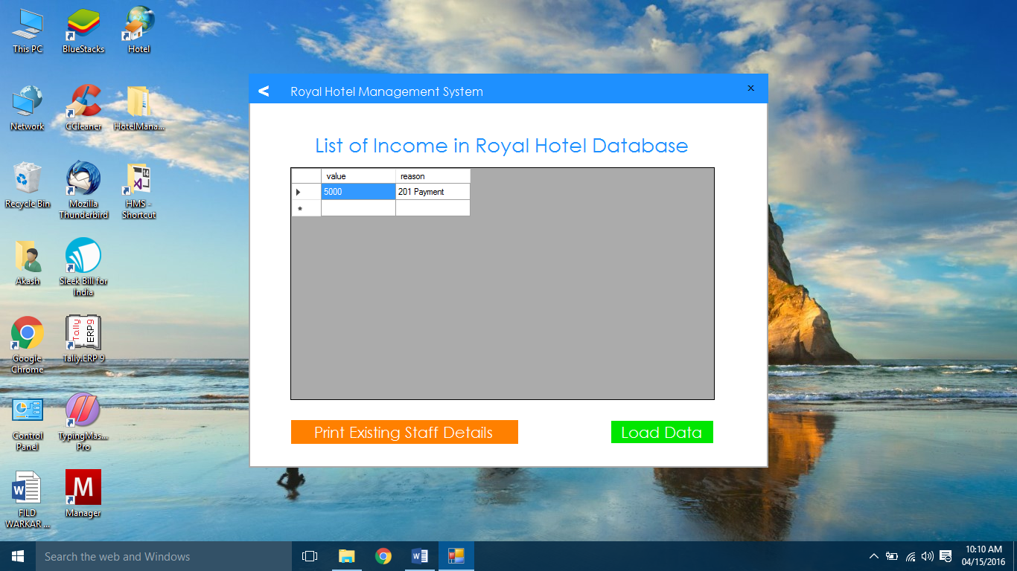



Step 8: Click on PRINT EXISTING STAFF DETAILS to Download & Print Data.

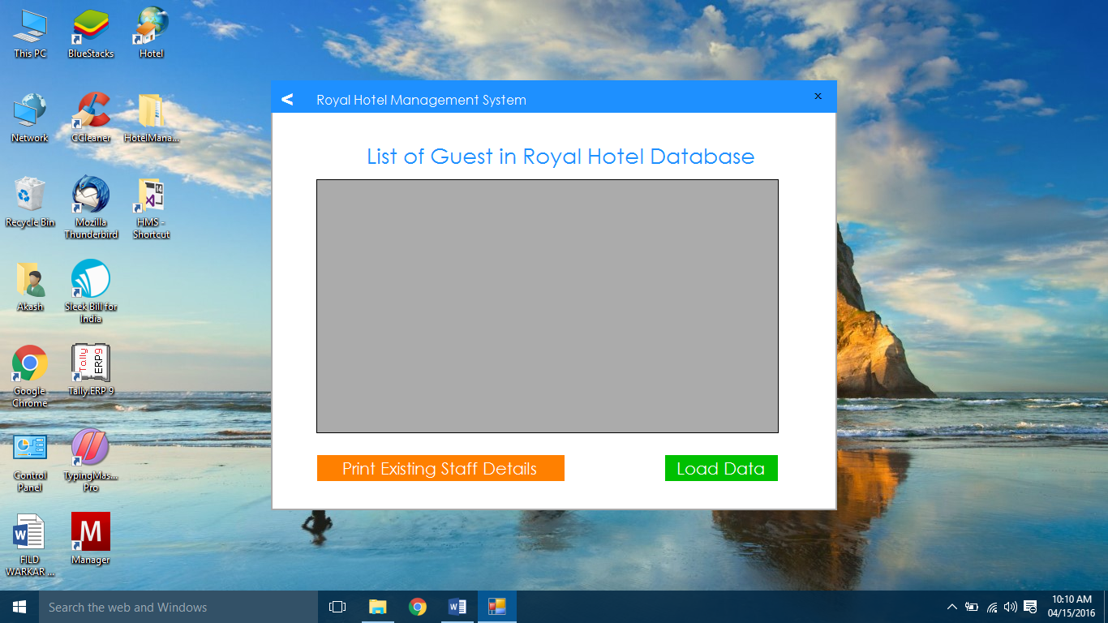

1. **How to Manage FOOD ORDERS**

Step 1: Click on the FOOD ORDER Button in the FrontDesk Dashboard

Step 2: You get to see three buttons.

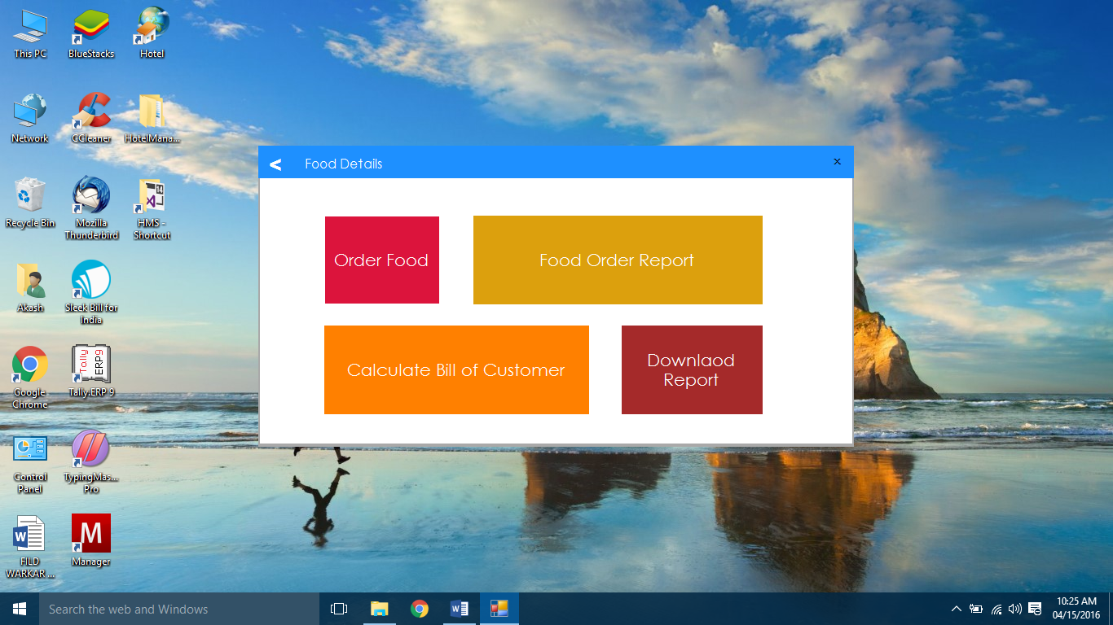

Step 3: To order food, Click on ORDER FOOD.

Step 4: Fill in the Details accordingly.

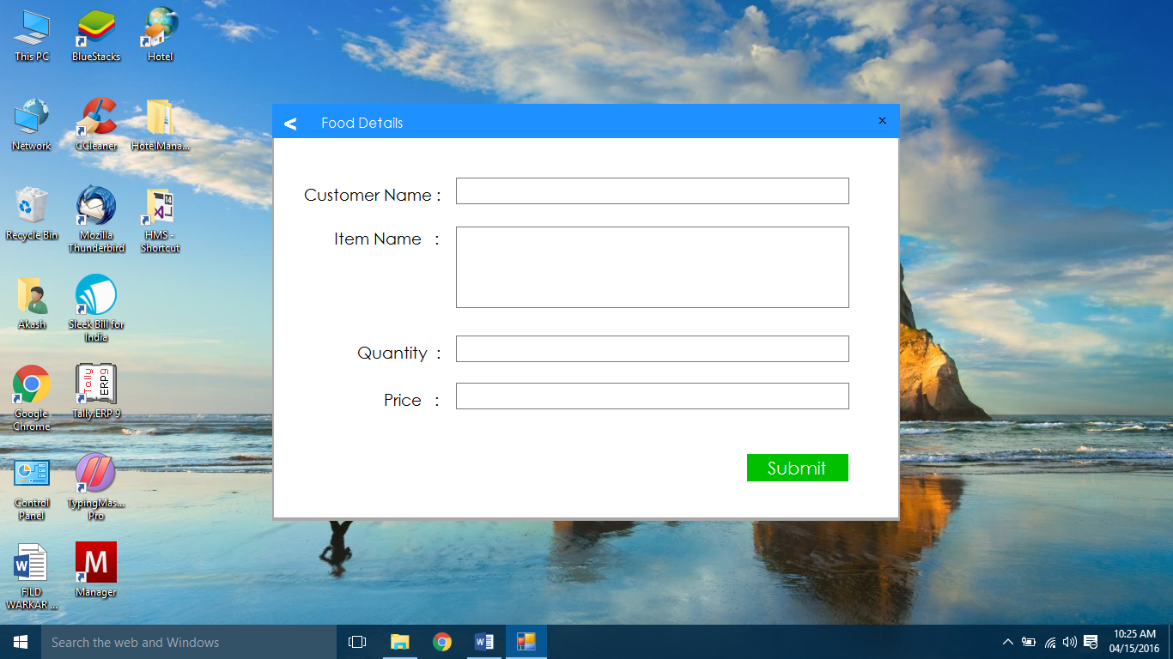

Step 5: Click on submit to save data.

Step 6: To View DATA go back and click on VIEW FOOD ORDERS Button.

Step 7: Click on LOAD DATA to view the DATA.

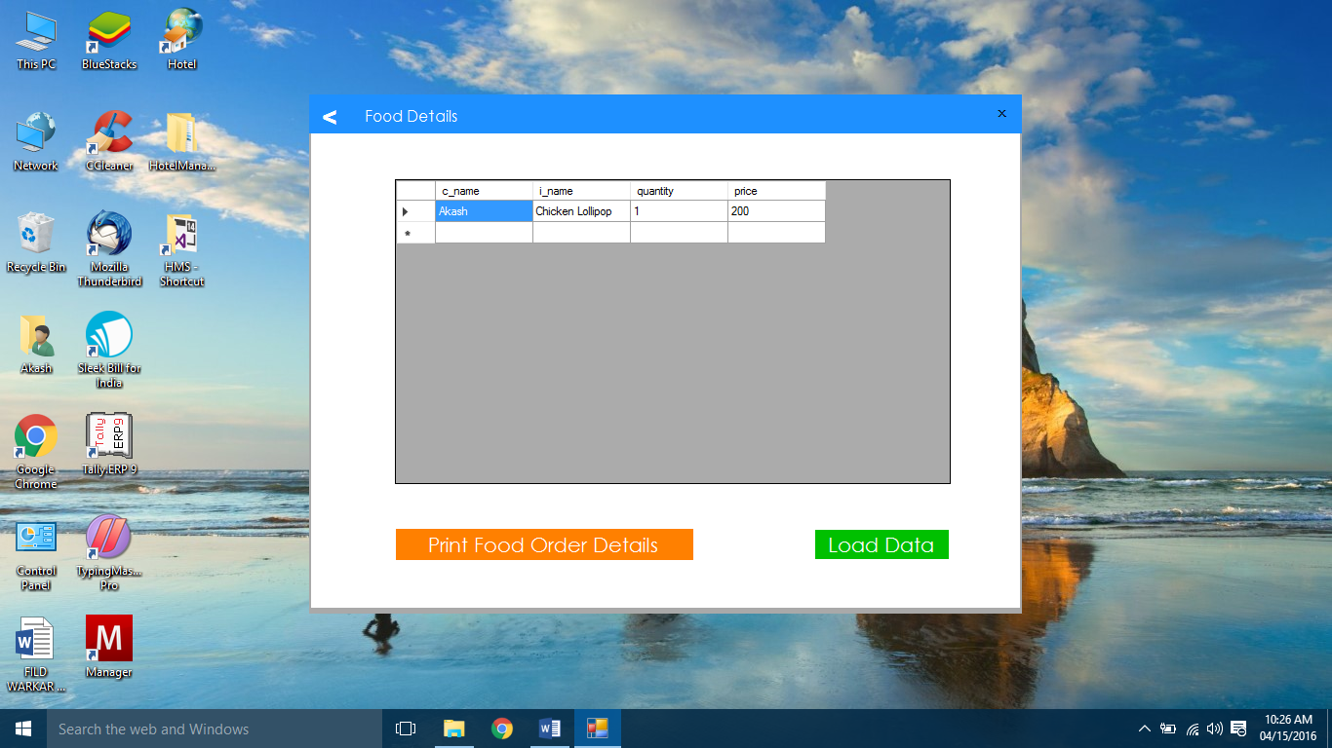

Step 8: Click on PRINT Food order DETAILS to Download & Print Data.

Step 9: Click on CALCULATE BILL OF CUSTOMER, Fill in the amount and click on CALCULATE to get the TOTAL.

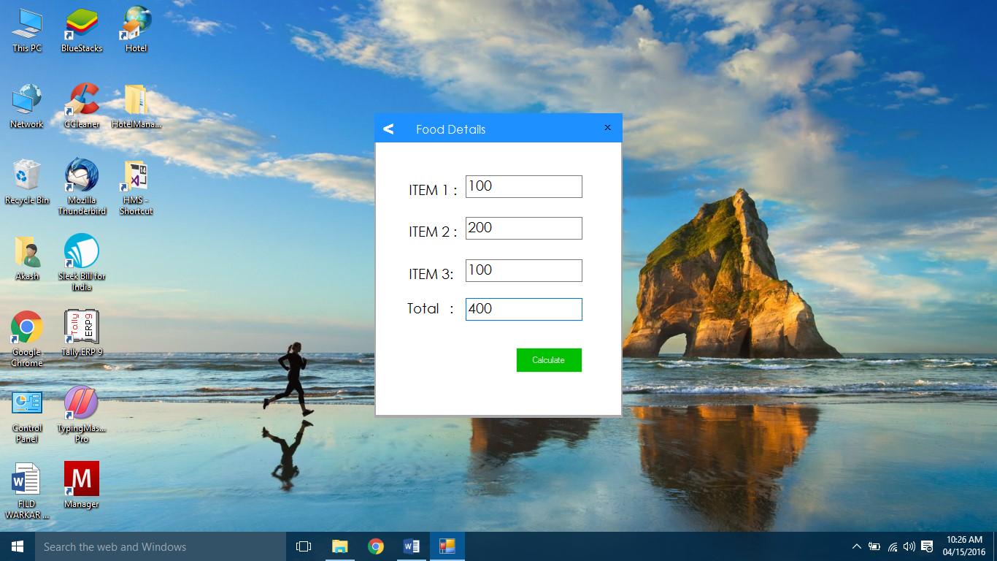

1. **How to Make Notes**

Step 1: Click on MAKE NOTE to make important Notes.

Step 2: Enter the details you want to save in note.

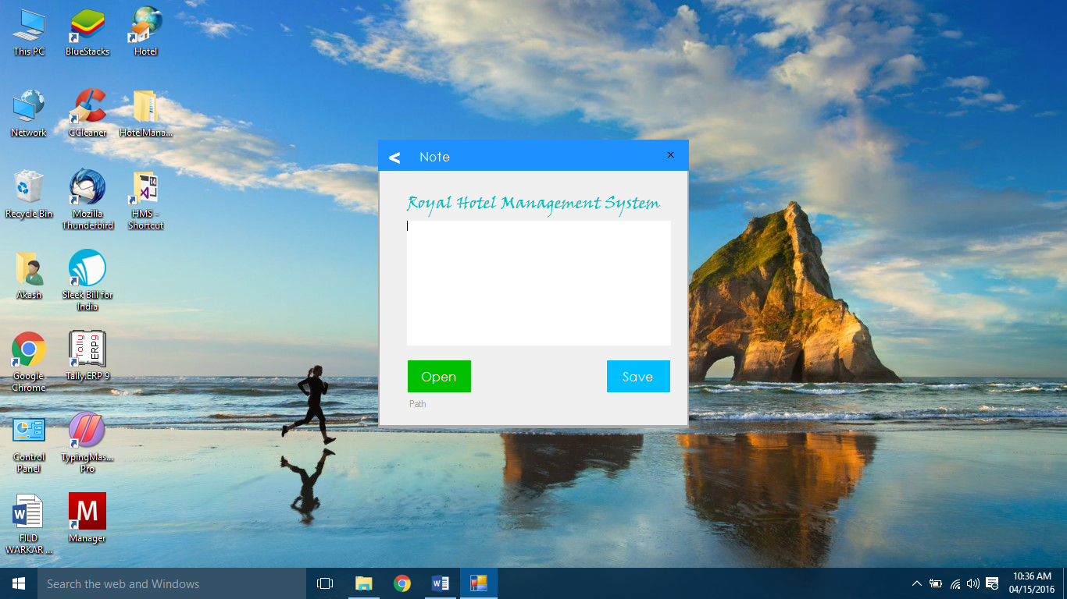

Step 3: Click on SAVE and select the Path (save the note with “.txt” Extension for easy access).

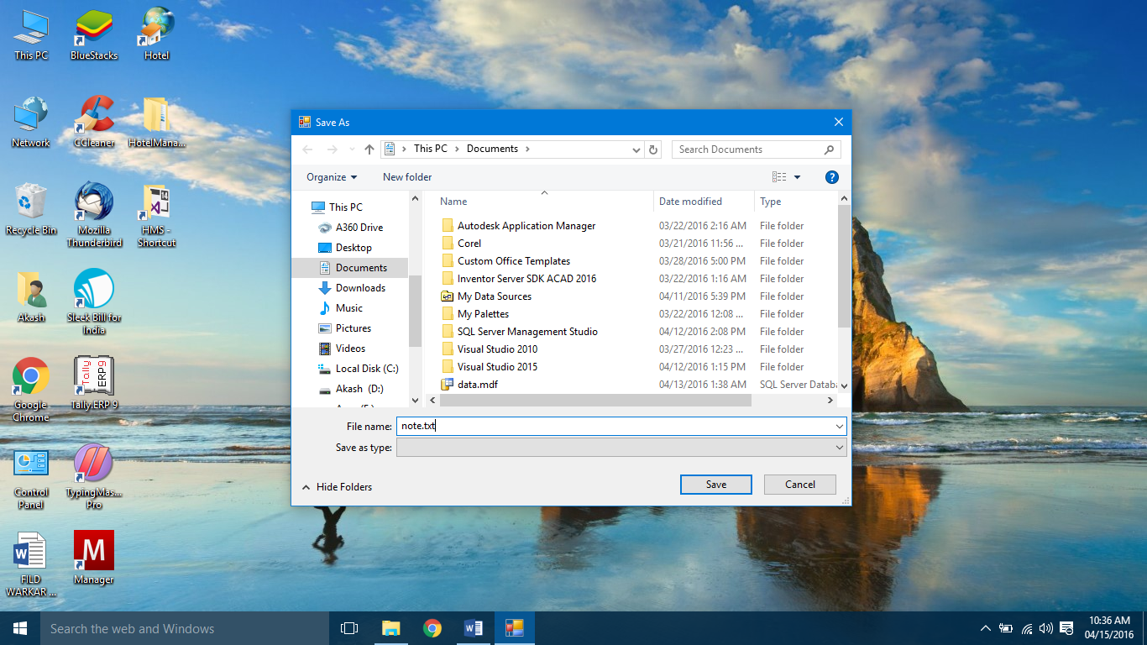

Step 4: To OPEN a file click on OPEN and select the FILE.

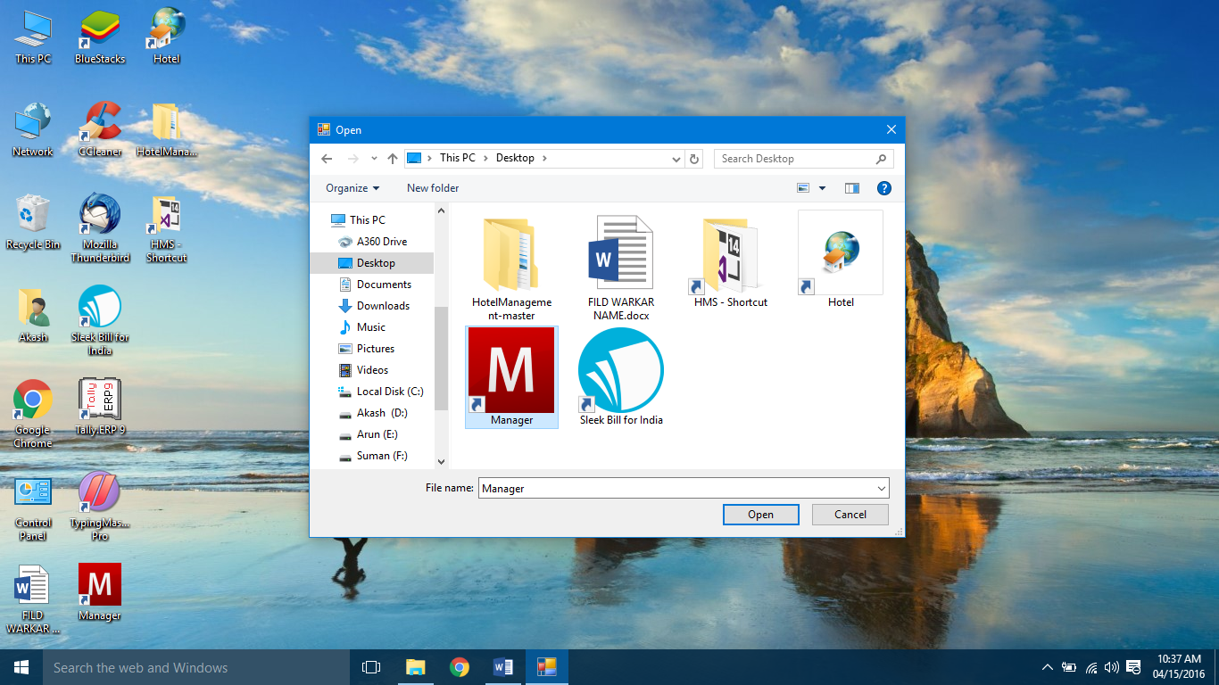

**ADMIN PANEL**

1. **How to login**

If you want to add some users click on the Setting Icon to get the Administrator Login Page, you can only login here if you have the given Password.

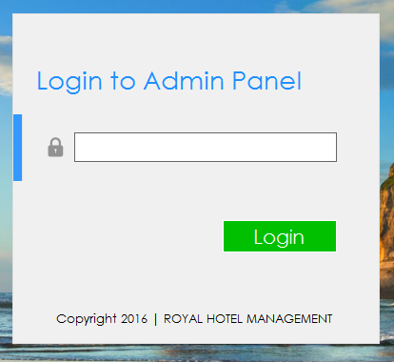

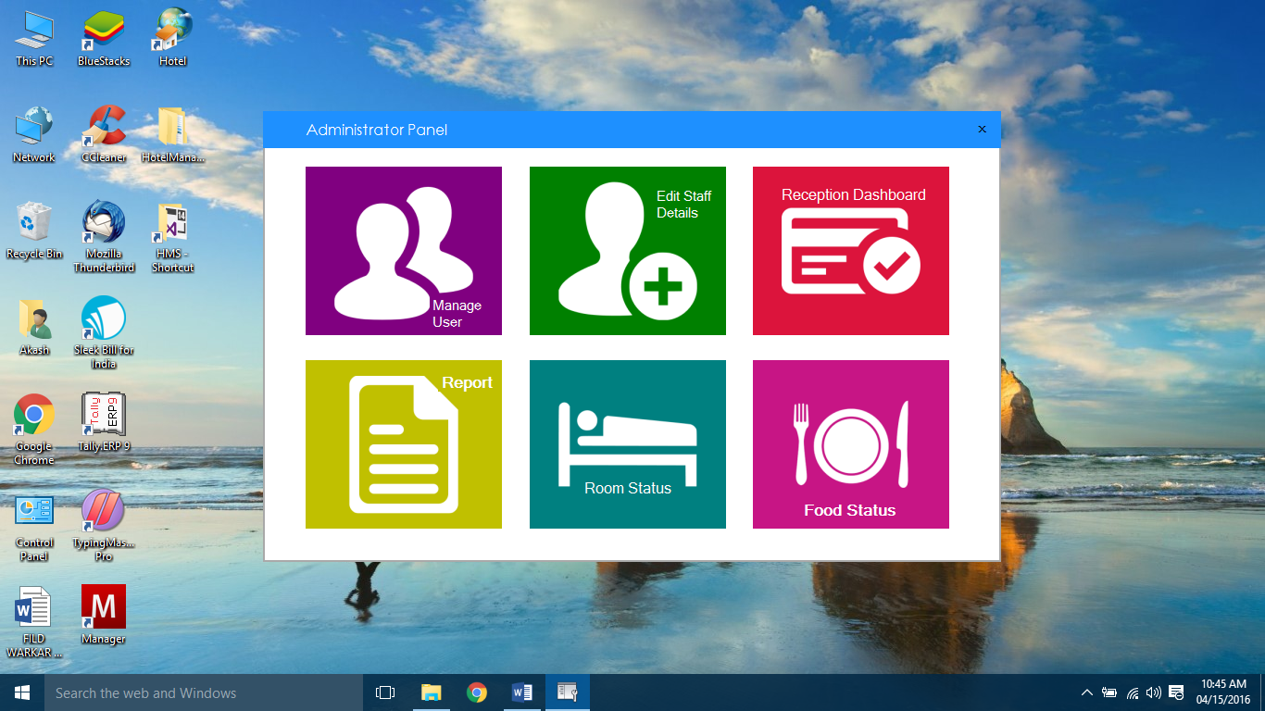

FrontDesk Dashboard

1. **How to add a User**

Step 1: Click On the MANAGE USER Button in the Dashboard

Step 2: Fill In the details properly as per given by the User.

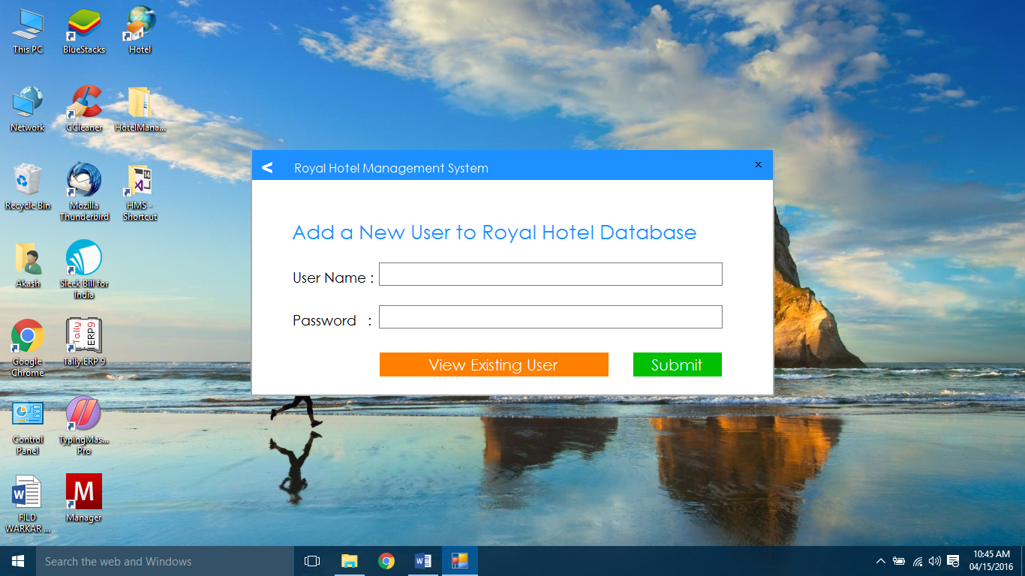

Step 3: Click on the “SUBMIT” Button.

Step 4: A Dialogue Box appears asking permission click on OK



Step 5: Click on LOAD DATA Button to view DATA.

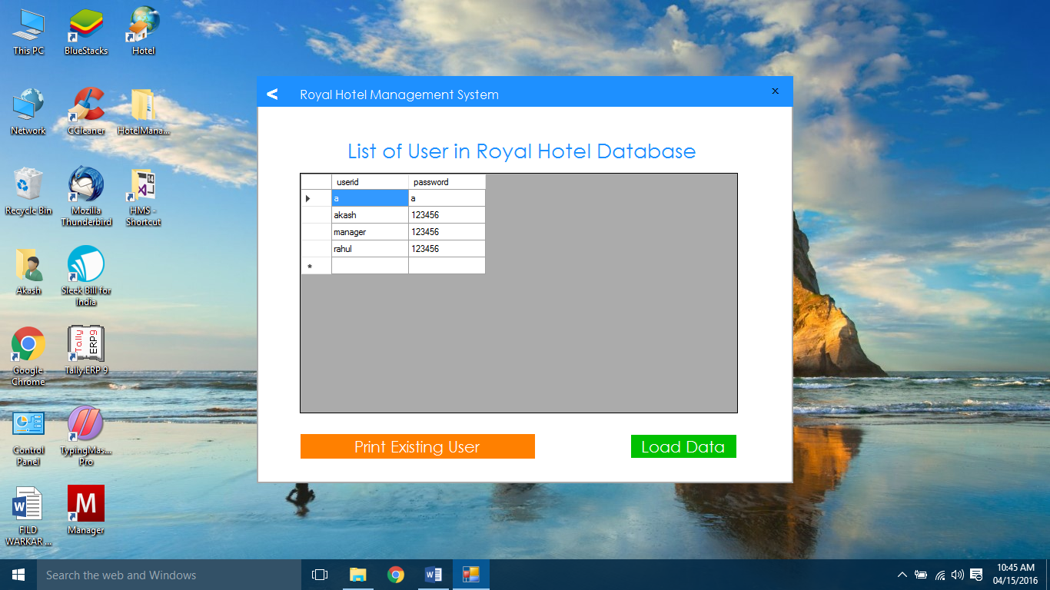

Step 6: Click on Print Existing User Button to Download and print DATA.



1. **How to Manage your STAFF**

Step 1: Click on EDIT STAFF DETAILS Button in the Dashboard

Step 2: You get to see three buttons.

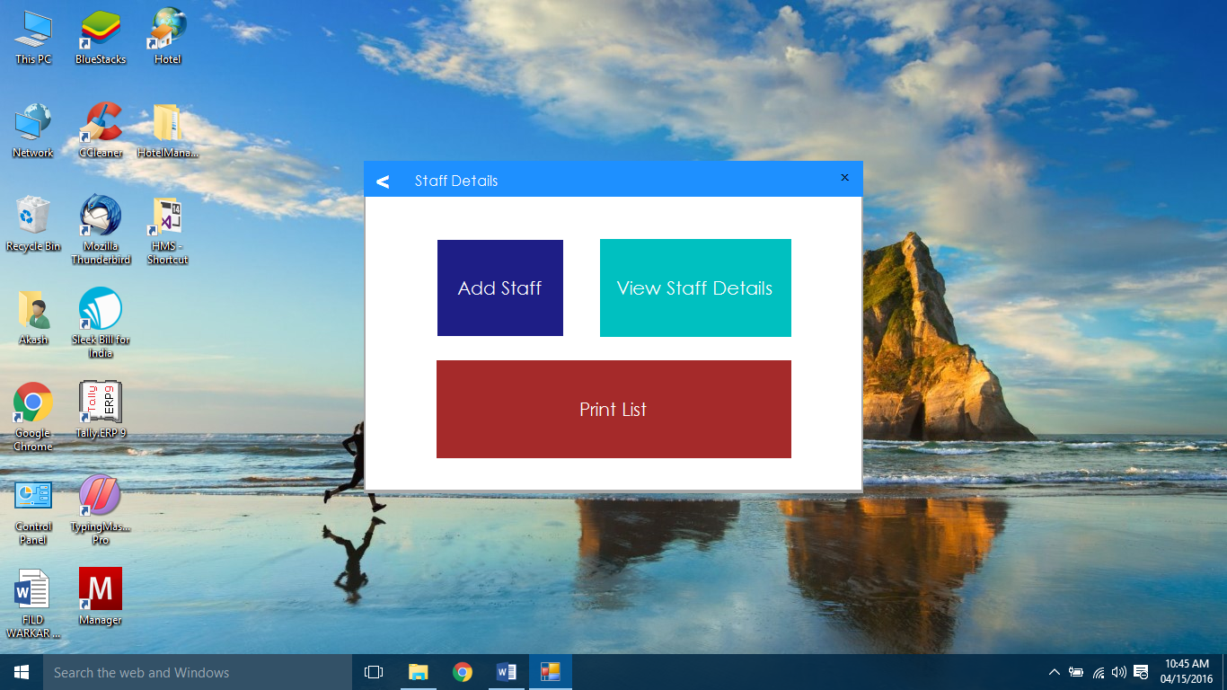

Step 3: To ADD Staff, Click on Add Staff Button and click submit.

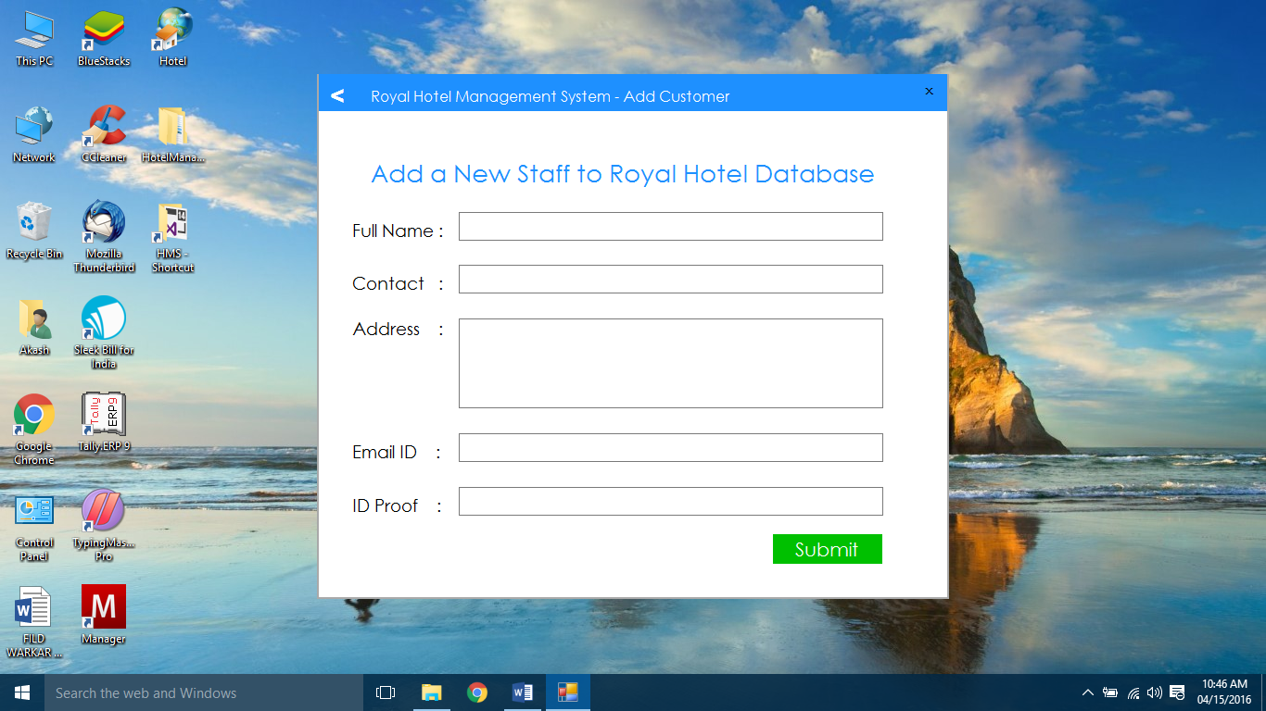

Step 4: To view the Guest List Click on the View Guest List Button.

Step 5: Click On load Data to See the Data.

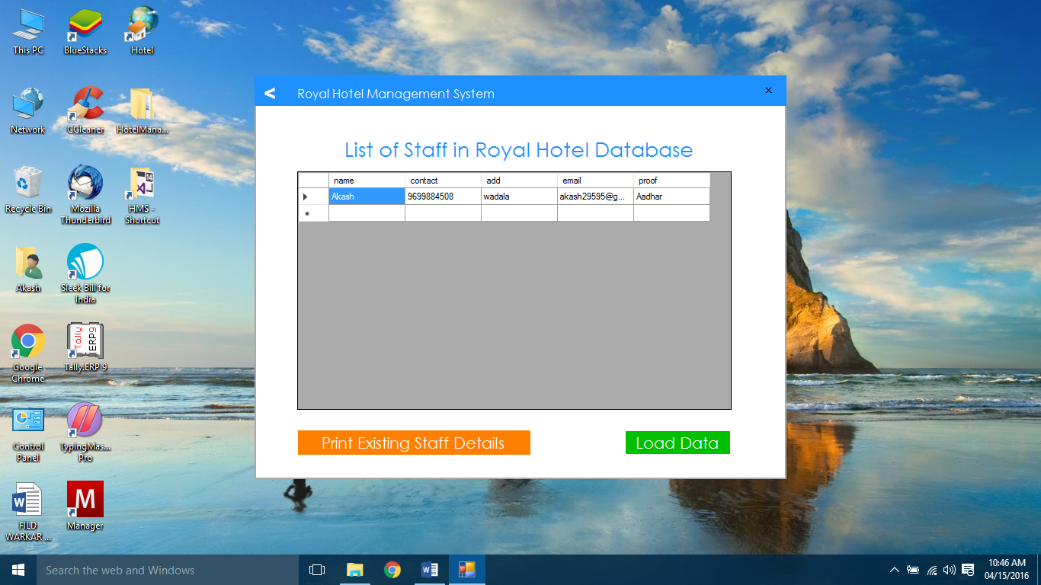

Step 6: Click on PRINT EXISTING STAFF DETAILS to Download & Print Data.